Heptagonal Cupola
# Source: AI Source: Provided by: [Data Path: Persons Table -> ID Column: 1, Name_En Column: Motasem Essam] -> From: [ChatGPT] on [7/25/2026]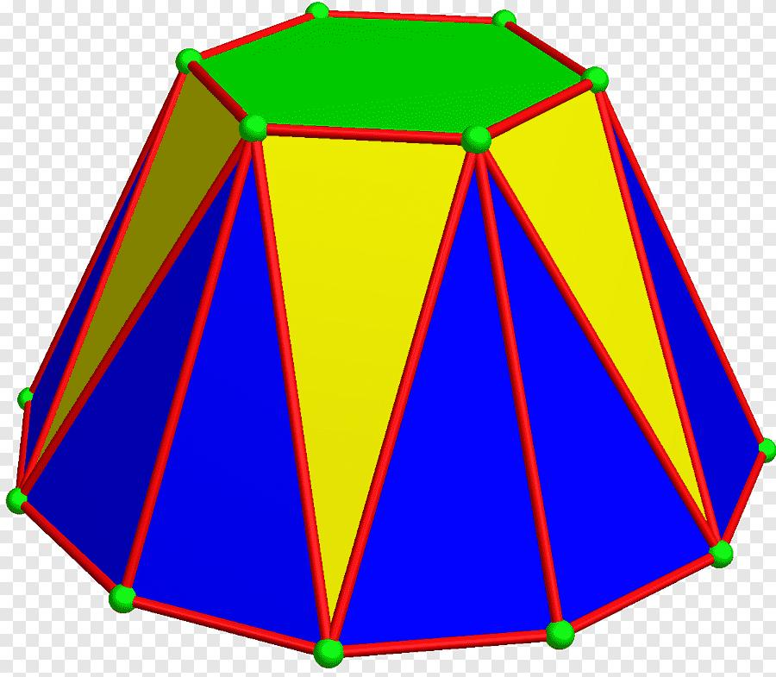

Definition
# Source: AI Source: Provided by: [Data Path: Persons Table -> ID Column: 1, Name_En Column: Motasem Essam] -> From: [ChatGPT] on [7/25/2026]
A Heptagonal Cupola is a three-dimensional polyhedron formed by connecting two parallel polygonal bases:
- One heptagonal upper base (7 sides).
- One tetradecagonal lower base (14 sides).
- Seven triangular lateral faces.
- Seven rectangular lateral faces.
The triangular and rectangular lateral faces alternate around the solid.
Important: Unlike the triangular, square, and pentagonal cupolas, the heptagonal cupola is not a Johnson solid. Its lateral faces cannot all be regular triangles and squares while retaining the standard convex cupola structure. <Cite refs={["turn654535search0","turn654535search2","turn654535search17"]}/>

Geometric Structure
# Source: AI Source: Provided by: [Data Path: Persons Table -> ID Column: 1, Name_En Column: Motasem Essam] -> From: [ChatGPT] on [7/25/2026]
- Upper Base: A regular heptagon.
- Lower Base: A 14-sided polygon (tetradecagon).
- Lateral Faces: Fourteen faces arranged alternately:
- 7 isosceles triangles.
- 7 rectangles.
- Arrangement: The heptagonal upper base is positioned above the tetradecagonal lower base, with alternating triangular and rectangular faces connecting their edges.

Face Composition
# Source: AI Source: Provided by: [Data Path: Persons Table -> ID Column: 1, Name_En Column: Motasem Essam] -> From: [ChatGPT] on [7/25/2026]
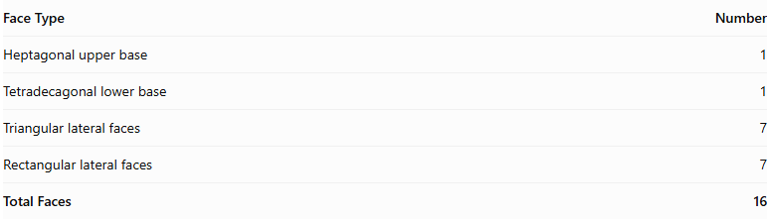
Face Type | Number
Heptagonal upper base | 1
Tetradecagonal lower base | 1
Triangular lateral faces | 7
Rectangular lateral faces | 7
Total Faces | 16

Mathematical Properties
# Source: AI Source: Provided by: [Data Path: Persons Table -> ID Column: 1, Name_En Column: Motasem Essam] -> From: [ChatGPT] on [7/25/2026]
For an $n$-gonal cupola, the general counts are:
$$F=2n+2, E=5n, V=3n$$
For a heptagonal cupola, $n=7$:
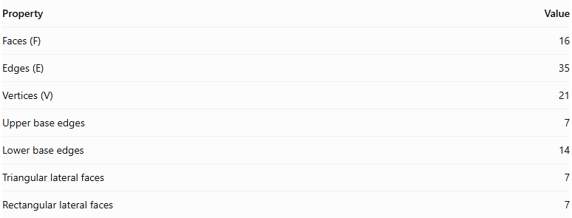
Property | Value
Faces (F) | 16
Edges (E) | 35
Vertices (V) | 21
Upper base edges | 7
Lower base edges | 14
Triangular lateral faces | 7
Rectangular lateral faces | 7
Euler's Formula:
$$V-E+F=2$$
$$21-35+16=2$$
<badge color="success">Euler's formula verified</badge>

Geometric Characteristics
# Source: AI Source: Provided by: [Data Path: Persons Table -> ID Column: 1, Name_En Column: Motasem Essam] -> From: [ChatGPT] on [7/25/2026]
- The two polygonal bases are parallel.
- The upper base has 7 vertices.
- The lower base has 14 vertices.
- The lateral faces alternate between triangles and rectangles.
- The solid can have rotational symmetry of order 7.
- Its lateral faces are not all regular polygons.
- It can be constructed as a convex prismatoid.

Constructing Heptagonal Cupola in Solid Geometry

Geometric Instruments Used
# Source: AI Source: Provided by: [Data Path: Persons Table -> ID Column: 1, Name_En Column: Motasem Essam] -> From: [ChatGPT] on [7/25/2026]
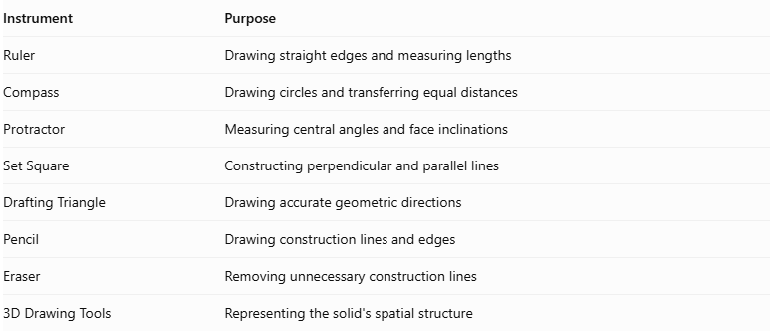
Instrument | Purpose
Ruler | Drawing straight edges and measuring lengths
Compass | Drawing circles and transferring equal distances
Protractor | Measuring central angles and face inclinations
Set Square | Constructing perpendicular and parallel lines
Drafting Triangle | Drawing accurate geometric directions
Pencil | Drawing construction lines and edges
Eraser | Removing unnecessary construction lines
3D Drawing Tools | Representing the solid's spatial structure

Instrument-Based Construction Procedures
# Source: AI Source: Provided by: [Data Path: Persons Table -> ID Column: 1, Name_En Column: Motasem Essam] -> From: [ChatGPT] on [7/25/2026]
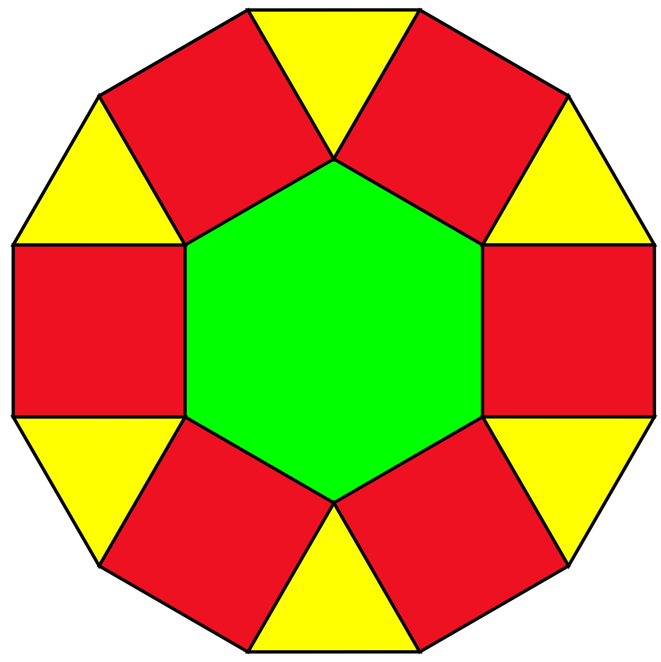

Constructing the Tetradecagonal Base
# Source: AI Source: Provided by: [Data Path: Persons Table -> ID Column: 1, Name_En Column: Motasem Essam] -> From: [ChatGPT] on [7/25/2026]
- Draw a circle using a compass.
- Divide the circle into fourteen equal angular sections using a protractor, with a central angle of:
$$\frac{{360}^{°}}{14}≈{25.714}^{°}$$
- Mark the fourteen points on the circumference.
- Connect consecutive points using a ruler.
- Complete the regular tetradecagonal base.

Constructing the Heptagonal Upper Base
# Source: AI Source: Provided by: [Data Path: Persons Table -> ID Column: 1, Name_En Column: Motasem Essam] -> From: [ChatGPT] on [7/25/2026]
- Draw a regular heptagon using a ruler and protractor.
- Make each side equal to the required common edge length.
- Position the heptagon parallel to the tetradecagonal base.
- Align the seven upper vertices with the appropriate alternating positions around the lower base.
- Establish the required perpendicular separation between the two base planes.

Constructing the Lateral Faces
# Source: AI Source: Provided by: [Data Path: Persons Table -> ID Column: 1, Name_En Column: Motasem Essam] -> From: [ChatGPT] on [7/25/2026]
- Identify the seven alternating vertex groups around the tetradecagonal base.
- Connect the appropriate lower-base vertices to the seven vertices of the upper heptagon.
- Construct seven square lateral faces between the corresponding base edges.
- Construct seven triangular lateral faces between the square faces.
- Check that the triangular and square faces alternate around the solid.
- Ensure that all shared edges have matching lengths.

Finalizing the Solid
# Source: AI Source: Provided by: [Data Path: Persons Table -> ID Column: 1, Name_En Column: Motasem Essam] -> From: [ChatGPT] on [7/25/2026]
- Draw the visible edges using continuous lines.
- Represent hidden edges using dashed lines where necessary.
- Check the arrangement of all sixteen faces.
- Verify that the heptagonal upper base and tetradecagonal lower base are parallel.
- Erase unnecessary construction lines.
- Complete the three-dimensional representation.
Construction note: This is an instrument-based geometric construction using rulers, compasses, protractors, and geometric relationships. It is not coordinate-based construction. A protractor can be used to mark the required angular divisions for practical drawing.

Key Points
# Source: AI Source: Provided by: [Data Path: Persons Table -> ID Column: 1, Name_En Column: Motasem Essam] -> From: [ChatGPT] on [7/25/2026]
- A Heptagonal Cupola has a heptagonal upper base and a tetradecagonal lower base.
- It contains 7 triangular and 7 rectangular lateral faces.
- It has 16 faces, 35 edges, and 21 vertices.
- It is not one of the 92 Johnson solids.
- Its lateral faces are not all equilateral triangles and squares.

Classification
# Source: AI Source: Provided by: [Data Path: Persons Table -> ID Column: 1, Name_En Column: Motasem Essam] -> From: [ChatGPT] on [7/25/2026]
Solid Geometry
└── Types of Solids
└── Cupola
└── Types of Cupolas
└── Heptagonal Cupola

Conclusion
# Source: AI Source: Provided by: [Data Path: Persons Table -> ID Column: 1, Name_En Column: Motasem Essam] -> From: [ChatGPT] on [7/25/2026]
The Heptagonal Cupola is a generalized cupola formed by connecting a heptagonal base and a 14-sided base using seven alternating triangular faces and seven rectangular faces. It has 16 faces, 35 edges, and 21 vertices.
References:
- <Link ref="turn654535search0" title="Wolfram MathWorld – Cupola"/>
- <Link ref="turn654535search2" title="Cupolas – Geometric Construction and Types"/>

